- Purpose
This Work Instruction outlines the process for purchasing a ReportRighter subscription and how to give access to authorized users within your organization.
- Parent Documents

Document Number | Title
SOP5001 | ReportRighter

- Child Documents

Document Number | Title
VA5001b | ReportRighter Purchasing and Provisioning Tutorial

- Responsibility
  - It is the responsibility of the Software Validation Engineer to ensure that all documentation relating to the use and validation of ReportRighter is up to date and correct.
- Purchasing
  - On the ReportRighter page in Microsoft AppSource click the “Get it Now” button.
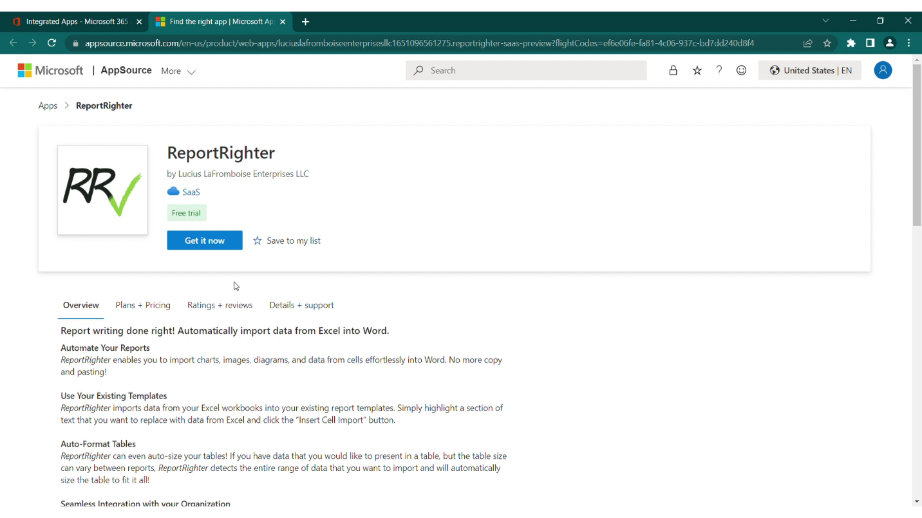
Figure 1. ReportRighter Microsoft AppSource Page

  - On the Select a plan page click “Next”
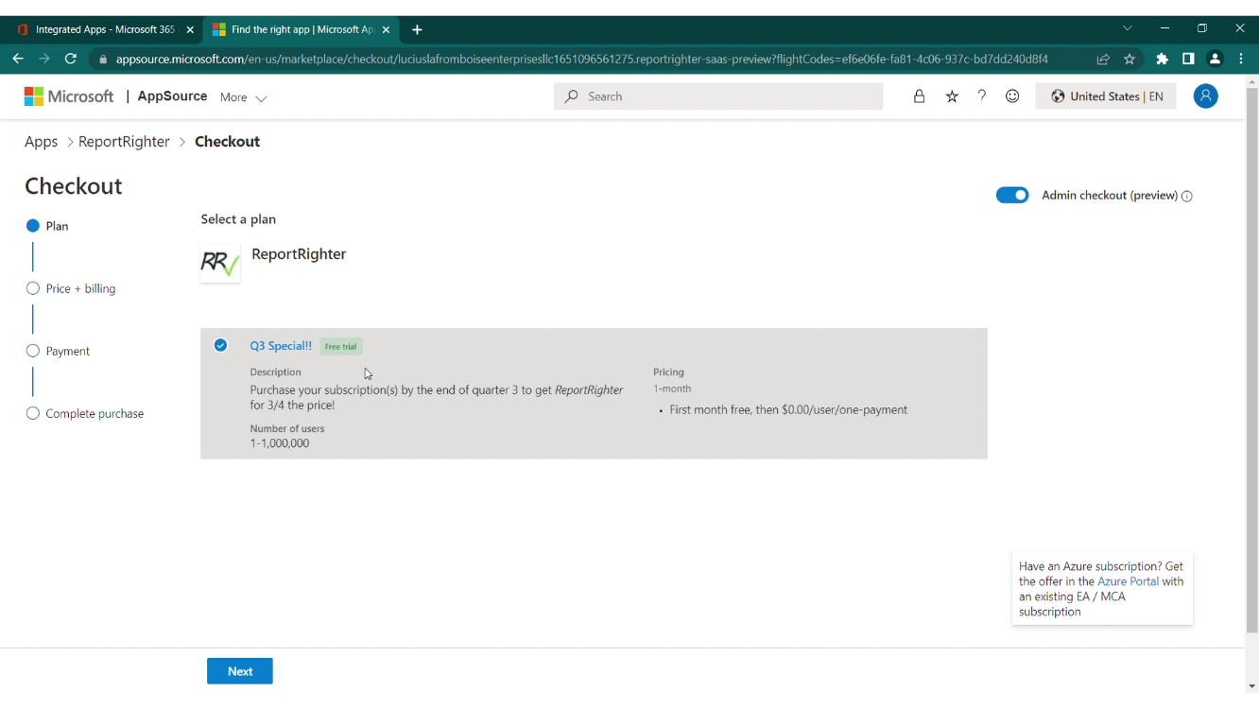
Figure 2. ReportRighter Microsoft AppSource Page 2
  - Leave Recurring Billing set to On. And select the number of users you would like to purchase a seat.
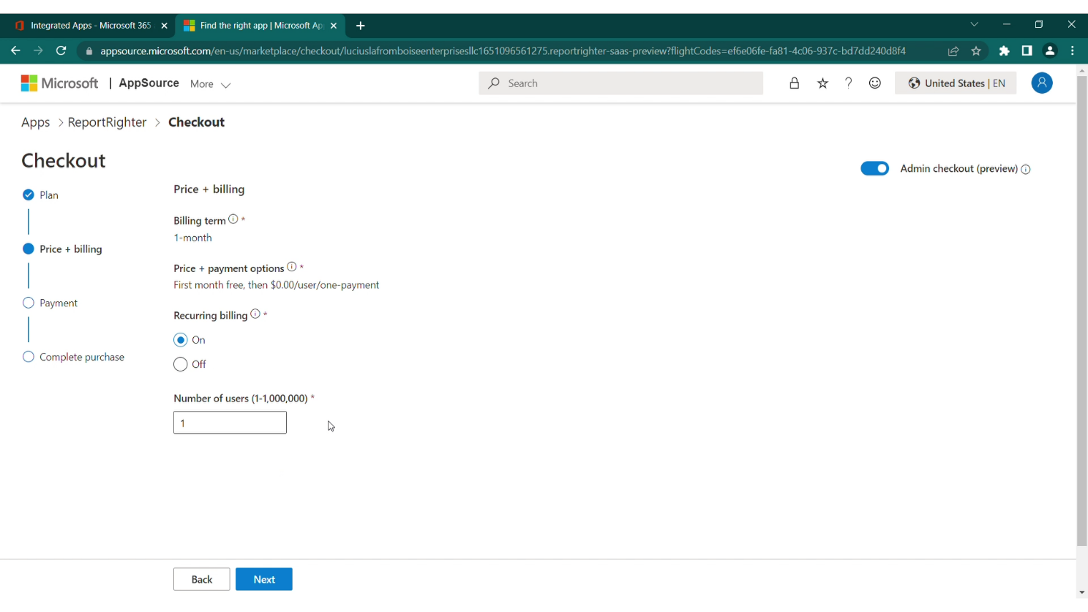
Figure 3. ReportRighter Microsoft AppSource Page 3
  - Review details to make sure everything is correct, then click Configure SaaS account button.
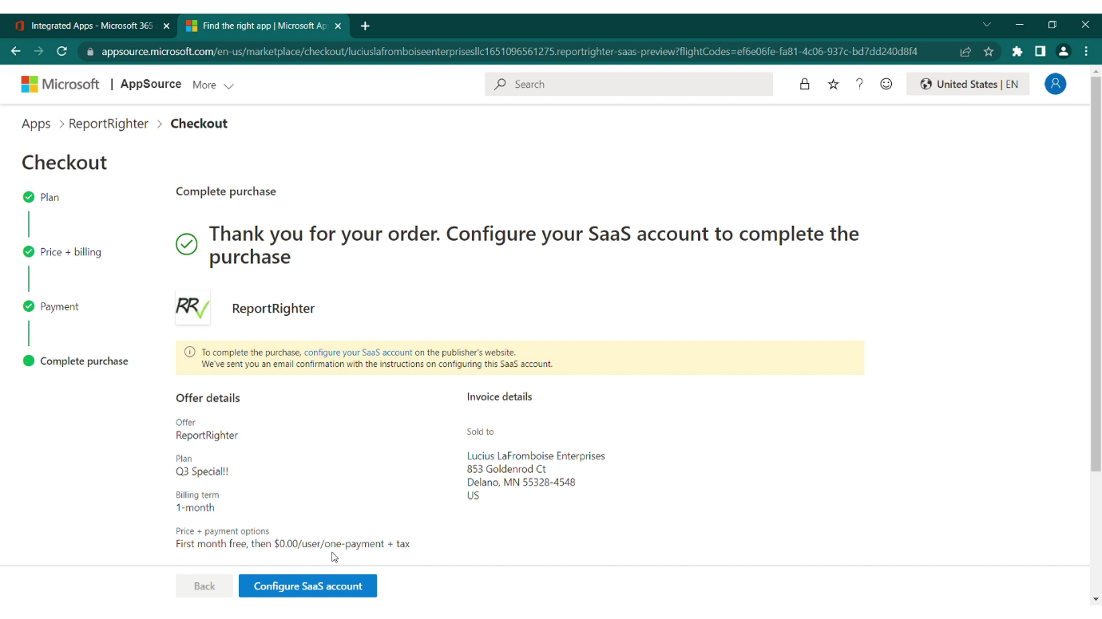
Figure 4. ReportRighter Microsoft AppSource Page 4
  - Give ReportRighter permissions and consent on behalf of your organization. Enter the name of your company in the Purchaser Tenant Name text box. Click Activate when you are ready to activate your account.
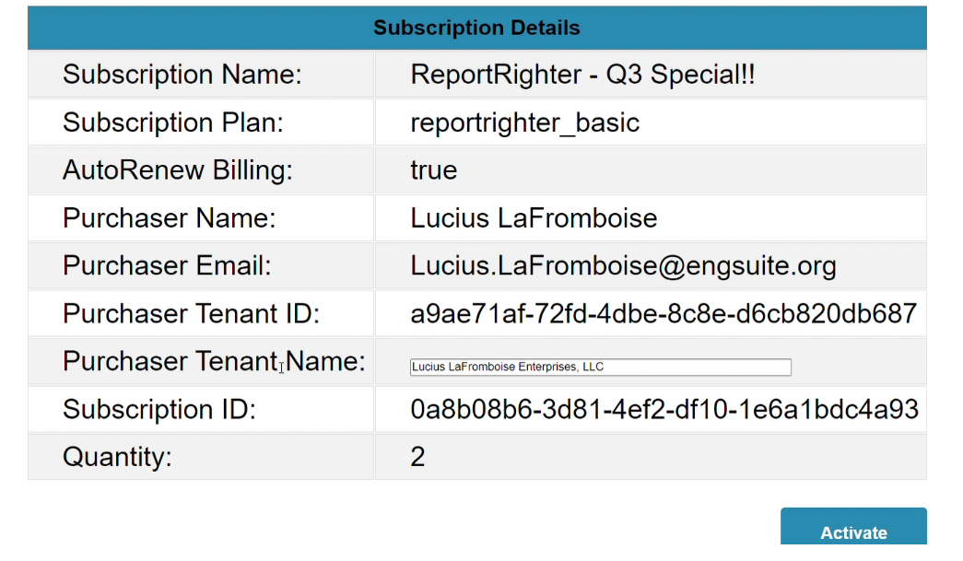
Figure 5. ReportRighter Landing Page

- Provisioning
  - On the EngSuite account manager page, scroll down to the authorized users section. Start typing the name of the user that you want to give access to in the User Name section. EngSuite will automatically search through your organization for users with this name and display them as suggested users. Click on the user that you want to provision access for, this will load their information into the table.
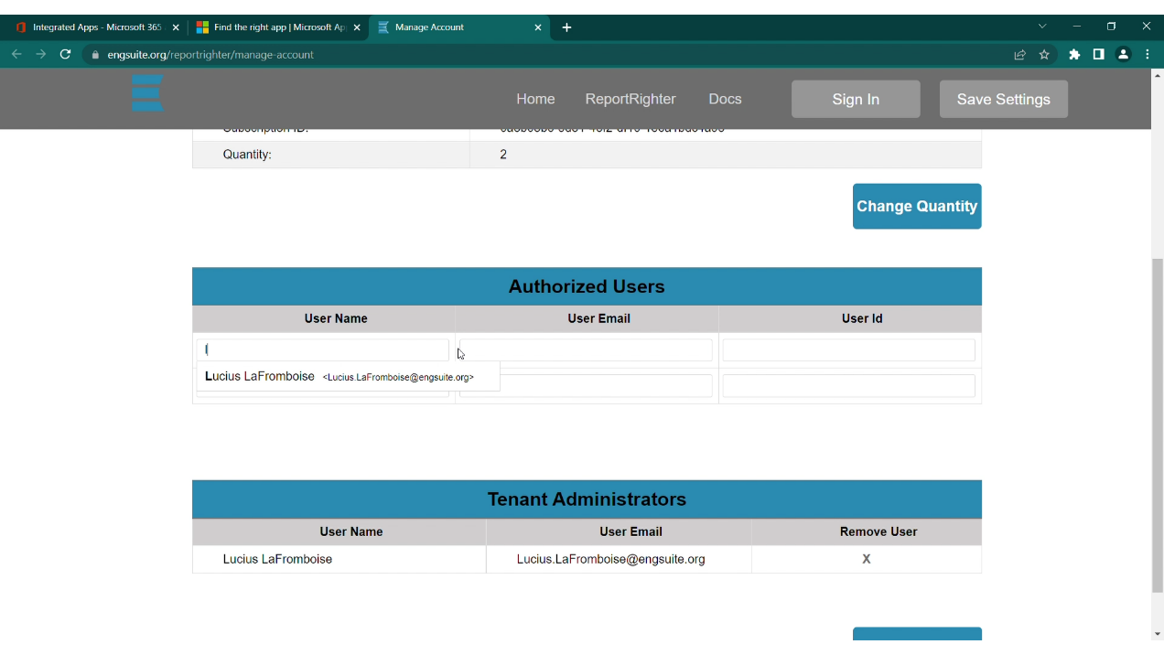
Figure 6. Adding authorized users
  - Repeat 6.1 for all users that you want to have ReportRighter access.
  - To give users admin access to the EngSuite account management page click the add user button and follow the instructions in 6.1 to add an authorized administrator.

  - Click save to authorize the users. Click the Save Settings button any time you have made changes that you want to save. You do not have to click save every time you add a new user but make sure to save before leaving the page.
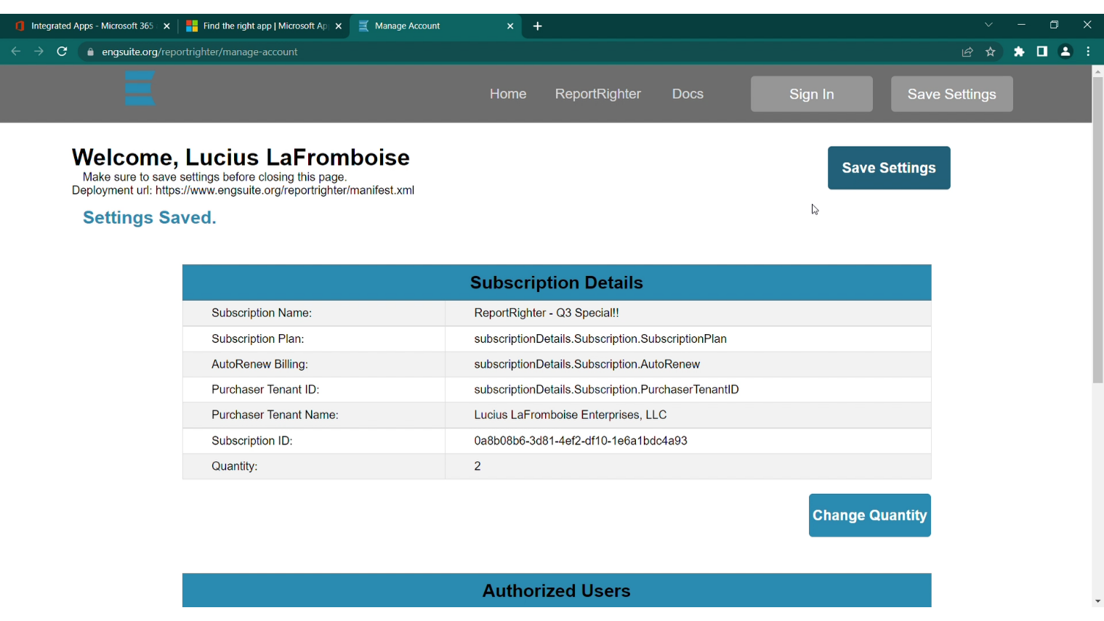
Figure 7. Save Settings

- Deployment
  - In your organization’s Microsoft Admin center go the Integrated Apps page and click the Upload custom apps button.
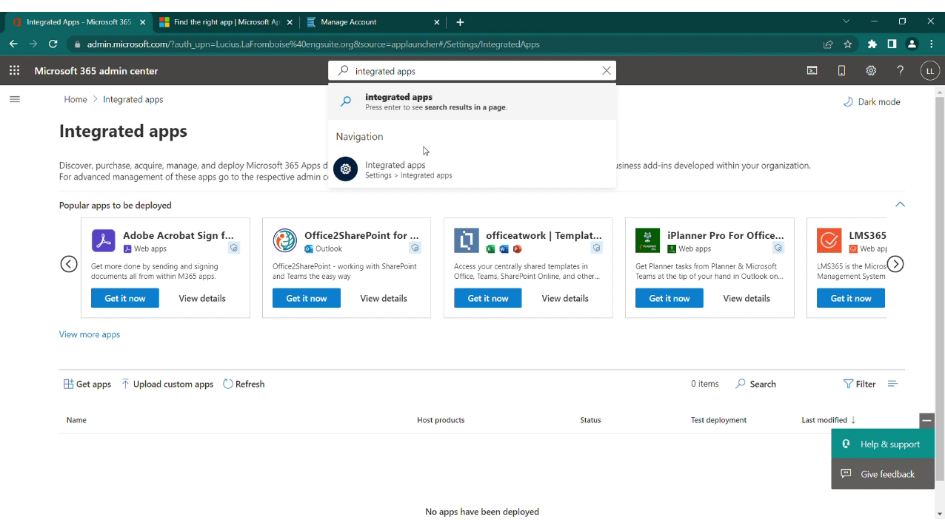
Figure 8. Integrated Apps Page

  - Select “Provide link to manifest file”. Insert the deployment url: www.engsuite.org/reportrighter/manifest.xml and click validate. After ReportRighter successfully validates click next.
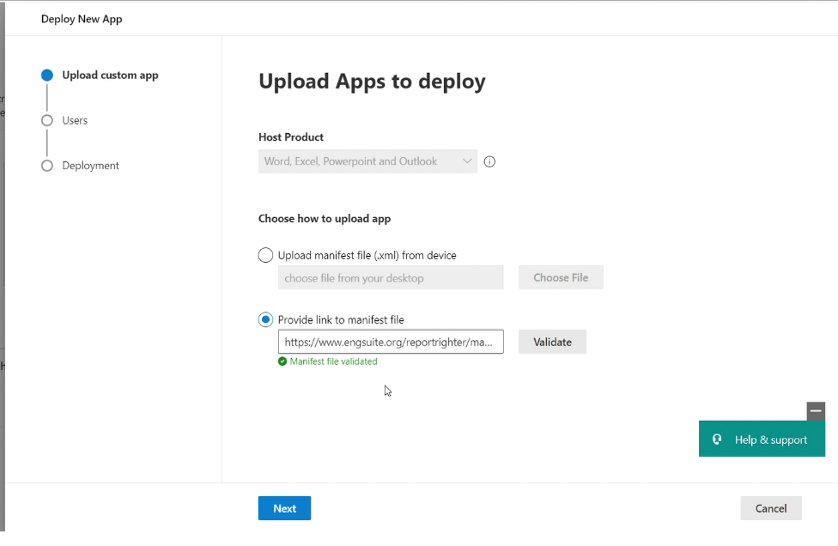
Figure 9. Provide Manifest Link
  - Select the users that you want to provision access. Do not deploy to anybody that is not an authorized user in the EngSuite manage account page. If ReportRighter is deployed to more users than you have purchased seats, you could be charged for the extra seats.
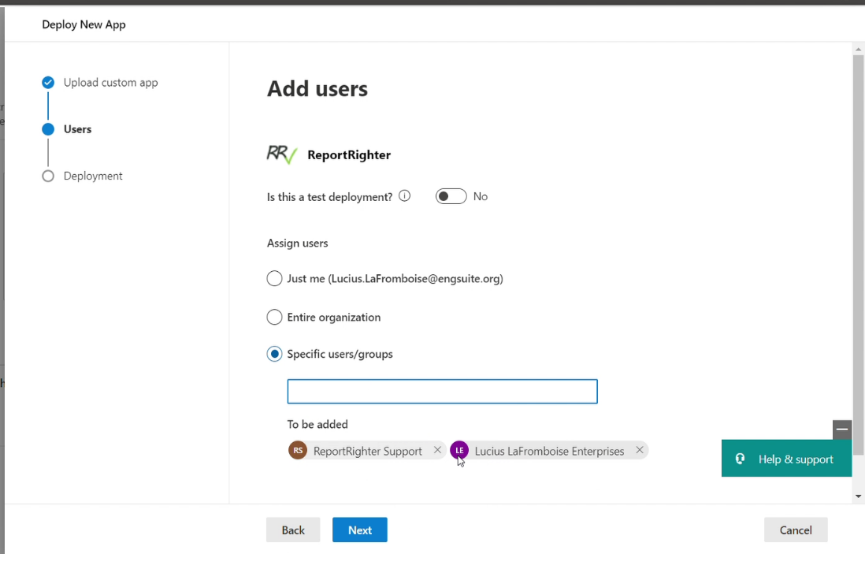
Figure 10. Deploy app to users
  - After selecting all authorized users click next. On the permissions page click Accept permissions then click next.
  - On the Review and finish deployment page click finish deployment. When it finishes deploying click Done.
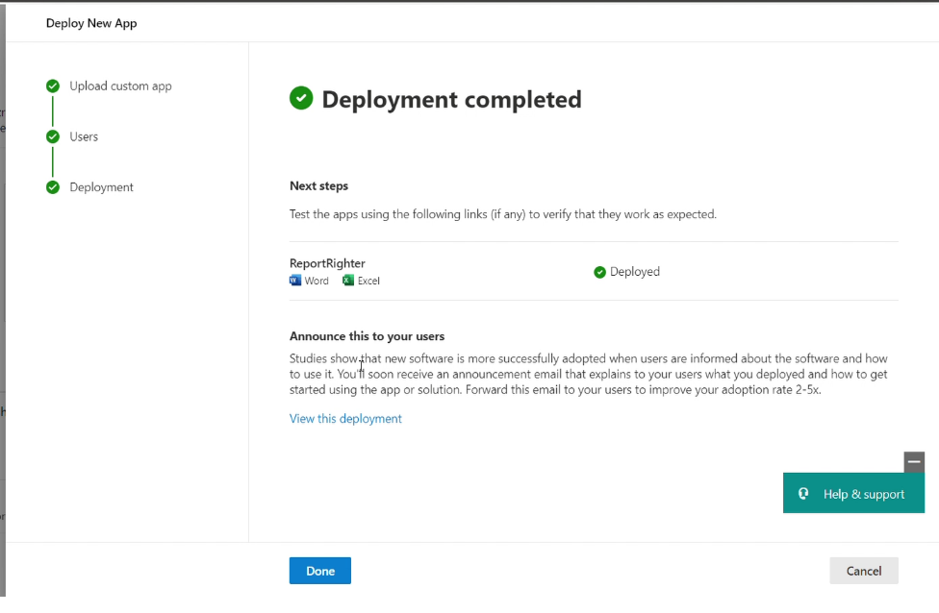
Figure 11. Deployment Complete
- Launching ReportRighter for the First Time
  - When a user first uses ReportRighter in Word/Excel they must load the add-in into Microsoft Office.
  - Click the Insert ribbon tab, then in the Add-ins group click My Add-ins.
Figure 12. My Add-ins button
  - In the My Add-ins window go to Managed Add-ins and Select ReportRighter.
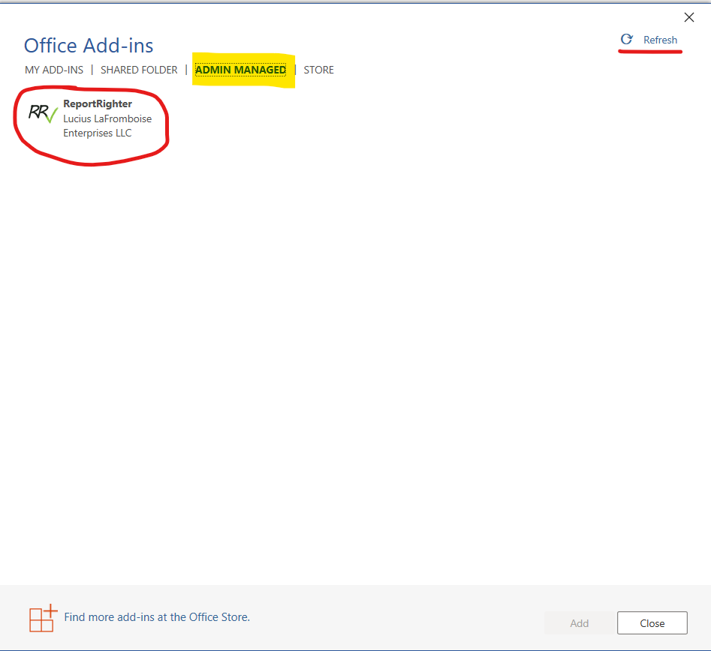
Figure 13. My Add-ins window
    - NOTE: If ReportRighter is not visible click refresh
- Troubleshooting
  - If your organization has not purchased a subscription to ReportRighter, when loading the ReportRighter task pane the following message will be shown.
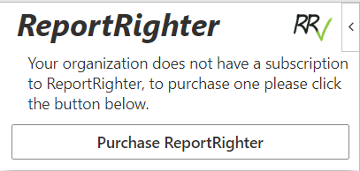
Figure 14. Organization does not have a subscription
    - If your organization has purchased a subscription and this message still appears, make sure that the account has been configured shown in section 6.
    - If the issue persists and the account has been configured, please contact support at rr.help@engsuite.org

